Assessment
POLICY

Date of Last Review: September 2019
Reviewed by: Headteacher
Approved: September 2019
Frequency of Review: Annually

Date of Next Review: September 2020

Assessment Policy

Assessment ‘for’, ‘as’ and ‘of’ learning.
Assessment is an essential part of the teaching and learning at Barr’s Hill School. Assessment for, assessment as and assessment of learning are approaches used by teachers to gather evidence and make judgements about student progress and achievement. These approaches may be used individually or together and formally or informally, for example formal assessment provides an opportunity to collect evidence of student learning and maybe used for grading purposes (assessment of learning) as well as informing feedback for students to improve their learning (assessment for learning).
Assessment for learning:

Assessment for learning is used to gather evidence about students' new knowledge and Procedural knowledge to inform their teaching. This is referred to as ‘formative assessment', it occurs throughout the teaching and learning process to clarify student learning and understanding. Formative feedback/marking is used to monitor student learning and to provide ongoing feedback that can be used by teachers to improve teaching and for pupils to improve their learning. Formative assessment allows teachers and pupils to assess attainment and progress frequently.

Assessment for learning
- reflects a view of learning in which assessment helps students learn better, rather than just achieve a better standard or grade
- involves formal and informal assessment activities as part of learning and to inform the planning of future learning, including targeted questioning
- includes clear goals for the learning activity
- provides effective feedback that motivates the learner and can lead to improvement
- reflects a belief that all students can improve
- encourages self-assessment and peer assessment as part of the regular classroom routines
- involves teachers, students and parents reflecting on evidence
- is inclusive of all learners.
Assessment as learning:
Assessment as learning is used when students are their own assessors. Students monitor their own learning/progress, ask questions and use a range of strategies to decide what they know and can do, and how to use assessment information for new learning.

Assessment as learning
- requires students to ask questions about their learning
- involves teachers and students creating learning goals to encourage growth and development
- provides ways for students to use formal and informal feedback and self-assessment to help them understand the next steps in learning
- encourages peer assessment, self-assessment and reflection
- encourages metacognition and self-regulated learning where students take responsibility for their own learning.

Assessment of learning:
Assessment of learning is used to support teachers in using evidence of student learning to assess achievement against outcomes. This is referred to as ‘summative assessment', it occurs at defined key assessment points or at the end of a unit, half term or term, and is used to assess students against standards or grades.

Assessment of learning
- is used to plan future learning goals and pathways for students
- provides evidence of achievement to the wider community, including parents, educators, the students themselves and outside groups
- provides a transparent interpretation across all audiences.
Barr’s Hill Expectations of Providing Feedback

- Barr’s Hill staff use the FAR marking approach in order to provide quality feedback on extended pieces of work.

Feedback – How well has the student achieved the success criteria for the task? What have they been successful with? Do the students know where they are at in their learning?

Action – What specific, subject related target will allow knowledge, understanding or skills to be developed further? What do they need to do to improve? This may be written in the form of a question for the student to answer. This could be re-writing specific paragraphs or re-attempting a task. Do they students know how to improve?

Response – Next to the ‘R’ students will respond to the action. This allows students to demonstrate improvements. Can the students show how to improve their learning/ work/ level/ grade?

- Students should be given time within the curriculum to proof-read and edit their work using green pen. Green pen should also be used when students are responding to FAR marking and improving their work. Green pen is also used for self-marking, shared/peer marking and paired marking.

- Literacy errors should be highlighted in students’ work, as appropriate to the student and subject. Staff are encouraged to do this when circulating in a lesson and/or as part of marking outside of lesson time. Errors should be corrected by the student.

Marking frequency

The frequency of marking will depend on the lesson allocation to each subject. Each department will have an agreed expectation for its staff. Core subjects such as English, Maths, Science and Humanities should assess work more frequently. Each student should have regular FAR marked work in each additional subject each half term.

Grading and written feedback

Students should regularly be given feedback on curriculum endpoints and their progress compared to their Target Grade. At KS4 and post-16 students should receive this feedback according to the grading structure of the qualification for which they are studying.

Monitoring

Heads of Department and Faculty are expected to sample the quality and quantity of marking of work in their subject area. Work samples form part of the evidence used for School and Faculty Self-evaluation. The views of students about marking and assessment will also be sought as part of a Faculty Review. Assessment grades are routinely collected from staff to share with colleagues and parents via Data Cycle progress reports.

Parents’ Involvement

Parents have a considerable contribution to make to students’ success in school. They are strongly encouraged to review their children’s school books, support students in responding to their teachers’ feedback and create the right environment and routines at home to enable homework to be completed. Liaison with the school is encouraged through use of the homework diary and via our Pastoral Leaders.

Other diagnostic testing

A fuller range of testing is also carried out where appropriate, to ascertain if and where certain students may need additional support (see SEND policy for more information). Currently, all students in years 7 & 8 have their reading and spelling ages tested twice yearly.

Reporting Assessment

For all key stages, we collect data at various, regular points throughout the year. To keep parents informed of students’ progress, all students will receive a progress report and opportunities for feedback to parents through targeted parents’ evenings/PRIDE Showcase days. Teachers also keep parents informed through regular contact with home. This process plays a key part in keeping students, staff and parents informed of students’ current progress.

The Senior Leadership Team and HOFs monitor the progress of the students throughout the year in an ongoing way, including through our RAP (Raising Attainment Panel) meetings for each year group.

Reporting

Data is collected for students at least three times a year. Reports are sent home to parents and discussed at Parent Showcase Days. The year 7 and year 8 report can be found in appendix A and the year 9, 10 and 11 report can be found in appendix B.

KS3 Assessment System

The following four descriptors will be used: Below beginning
Beginning
Developing
Secure
Expert

- Expert means the pupil is on track to achieve a grade 7 in year 11
- Secure means the pupil is on track to achieve a grade 5 in year 11
- Developing means the pupil is on track to achieve a grade 4 in year 11
- Beginning means the pupil is on track to achieve a grade 1 in year 11
Students will be assigned either red, amber or green on whether they are making expected progress. Green means on track, amber means slightly below and green means below. They will be assigned these colours in the following way:

GCSE ready? | Green | Amber | Red
Higher | E | S | Below S
Middle | S or higher | D | Below D
Lower | D or higher | B | Below B

The judgement to determine whether a pupil is Expert, Secure, Developing or Beginning is holistic and based on a range of factors including attitude to learning and performance in assessments.

Plagiarism and originality checking

Originality of work should be checked and explicitly taught and encouraged all through secondary school, but is particularly pertinent in KS4 and KS5. The school is committed to prevent and identifying plagiarism and as such, uses the commercial plagiarism software package ‘Turnitin’. Subjects with externally assessed coursework or units of work (which are completed in school) must use turnitin as part of the assessment processes. See below for the guidance document.

Other related policies / documents:

- Exams and Appeals policy
- Learning & Teaching policy
- SEND Policy
- Communications policy

Appendix A
Barr’s Hill School Report - Year 7 November 2019

Photo of student

Name of student
Tutor Group: 7C
Attendance: 92.2
Absences: 7
Unauthorised absences: 0
Explanation of this report
Academic
Attainment column
In this column there will either be an E, S, D, B, or BB. These stand for
Expert, Secure, Developing, Beginning or Below Beginning. This is a holistic judgement based on where your child is currently at within a subject.
The following can be used as a guide:
E – Displaying the ability and behaviour to achieve at least a grade 7 at GCSE.
S – Displaying the ability and behaviour to achieve at least a grade 5 at GCSE.
D - Displaying the ability and behaviour to achieve at least a grade 4 at GCSE.
B - Displaying the ability and behaviour to achieve at least a grade 1 at GCSE.
BB – Not displaying the ability and behaviour to achieve a grade 1 at GCSE.
Progress Column
This is based on your child’s attainment vs their attainment at primary school. This shows whether they are on track against their peers that achieved similar primary scores nationally. Green indicates they are on track in that subject, amber is slightly below and red is below.
Effort and Homework columns
In this column there will be an E, G, S, or U. These stand for Excellent, Good, Satisfactory (needs to improve) or Unsatisfactory.
Personal Development
PRIDE articulates our values and beliefs that shape the learning, behaviour and experiences of our students. It is doing the right thing at the right time in the right way. Pupils are awarded points when they display these behaviours, which can be spent at the rewards shop. The table below displays how many points your child has earned vs the average amount in the year group. Negative points are awarded for poor behaviour.

Academic

Subject | Attainment | Progress | Effort | Homework
English | E | On Track | E | E
Maths | E | On Track | E | E
Science | E | On Track | E | G
History | E | On Track | E | E

Personal Development

 | Proactive | Responsible | Inquisitive | Determined | Engaged | Negative Points
Name of student | 10 | 5 | 2 | 8 | 5 | 1
Year Average | 5.09 | 2.32 | 2.81 | 9.61 | 6.64 | 4.39

Appendix B
Barr’s Hill School Report - Year 11 November 2019

Photo of student here |  | How to understand this report:  - Behaviour and Effort: E = Excellent, G = Good, S = Satisfactory - requiring improvement, U = Unsatisfactory.  - Target Grade – this is the grade the student should aim to achieve by the end of year 11  - Predicted Grade – this is the grade the student is likely to achieve at the end of year 11 if they continue to work in the same way.  - Trail Exam grade – this is the grade the student achieved in their last trial exam.  In the Predicted Grade and Target Grade columns there are a number of different grades given depending on the course followed:  BTEC Distinction * (Di*) Distinction (Di)  Merit (M or L2 Merit) Pass (P or L2 Pass)  Level 1 Pass (or L1 Pass)  GCSE 9, 8, 7, 6, 5, 4, 3, 2, 1, U. 4.0/4.1 means just getting a 4. 4.8/4.9 means a strong 4 and close to a grade 5. Below is a table that indicates how the ‘old’ GCSE grades match up with the new.  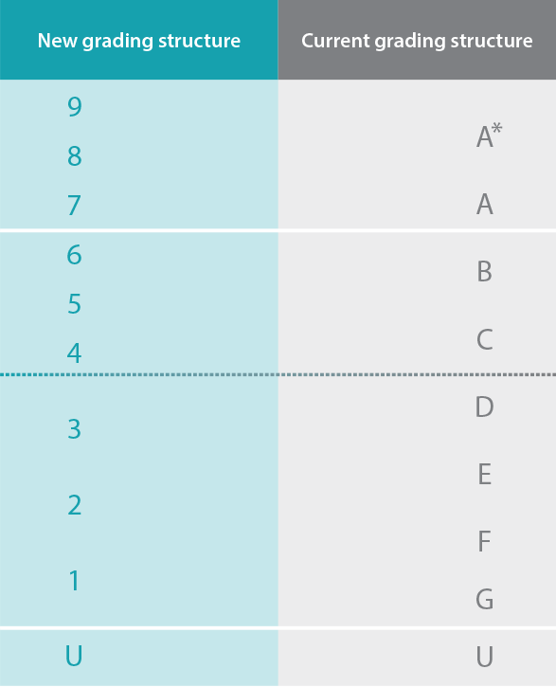
Name of student
Tutor Group: 11W
Attendance: 100.0
Absences: 0
Unauthorised absences: 0
PRIDE Points: 13
Behaviour Points: 0

Subject | Overall Target Grade | End Of Year 11 Predicted Grade | Effort Grade | Homework Grade
English Language | 8.5 | 9.0 | E | E
English Literature | 8.5 | 9.0 | E | E
Maths | 8.5 | 8.0 | E | E
Science (Biology) | 8.5 | 8.5 | E | E
Science (Chemistry) | 8.5 | 8.5 | E | E
Science (Physics) | 8.5 | 8.5 | E | E
History | 8.5 | 9.0 | E | E
Spanish | 8.0 | 8.2 | E | E

